**Chapter-1**

Introduction

* 1. **Project Profile**
  2. **Project Introduction**
  3. **Company Introduction**
  4. **Company Profile**





 **: School Management System (WEB Based).**

** : Microsoft wi0ndows 10.**

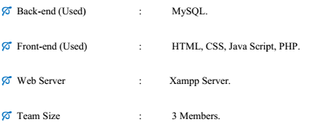



* **Adobe Photoshop CS3**
* **Adobe Dreamweaver CS5/ Sublime**
* **Xampp Server**



School System has to use both student as well as

staff as well as faculty. Student can view own result

And attendance and staff can view own subject

result and attendance. Admin can announce

anything to online so everyone can get it.

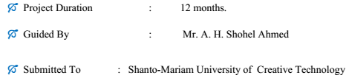

**1.2 Project Introduction**

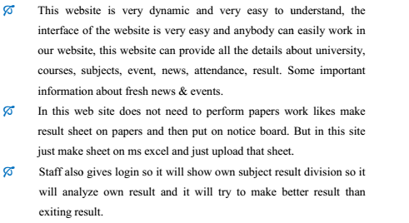**The Online School Management website is useful for the students, staff, parents who like to display Result as well attendance and the entire task like event, news, fresh assignment without going to school. It provides the facility to the students or parents to have complete information about the school.**

**The online school management website is also very useful because the student don’t have to read notice board, he can easily view all info. Like result via this website. To make this website work successfully we have used some latest technology such as PHP as the Development Platform, PHP frame work as the development and MYSQL as the Database Management environment**.

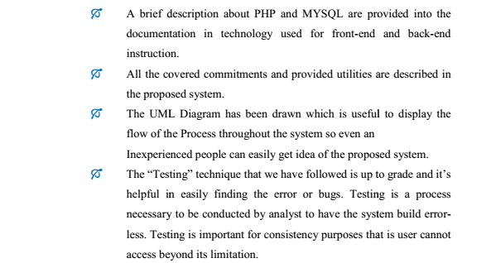

**1.3 Company Introduction**

**Cantonment Public School** was established in 2003 founded by **Mr. Md. Imamul Kabir Shanto.** The trust believes in multi-dimensional development of students which will make them able to serve the nation with their versatile qualities. In a short period of time

**CPS(Cantonment Public School)** amis to reach every nook and corner and wants to remove the darkness of ignorance. For this **CPS** has given a technical fight by bringing computer education through BCA programme. For making the society self reliant and healthy, **CPS** is trying to provide with sculptor of education through their B. Ed programme. The trust believes that progress of nation is only when the resources and finances are optimally utilized. This is possible only when the students are well versed with economics and finances. Thus, within a small span the university is trying to grow in every sphere of academy.

**1.4 Company Profile**

**About “Cantonment Public School”:**

* **Name** : **Cantonment Public School(RPS)**
* **Address : Cantonment Gazipur, Dhaka1230, Bangladesh.**
* **Contact No : +8802-123456**
* **E-mail :** [**info@cps.edu.bd**](mailto:info@cps.edu.bd)
* **Established Year : 2017**
* **Orag. Vision : Education**
* **Founded By :**
* **Managed By :**